Helping Users Find New Video Games Using Scraped Data
By Harry Martin
22nd of August 2025

Contents
Figures 3
Introduction 4
Literature Review 5
Why a Tagging Website? 5
What is Scraping? Why Use It? 6
Legal and Security Issues 7
GDPR 7
Computer Misuse Act 1990 8
STRIDE 9
Ad-Hoc Data Issue 10
Methodology 12
Design/Plan 13
Data Plan 13
Target Website 13
Scraping 14
Saving Format (.CSV) 16
Database (MySQL) 17
Scraping Practice 20
Development 23
Scraping Program 23
MySQL Database 24
Website 25
Results/Findings 26
Scraping Program & Data Analysis 26
MySQL Database 27
Website 28
Conclusion 29
References 30

Figures
Figure 1: Development Process 12
Figure 2: Steam's All Products Page 13
Figure 3: Steam Developers and Publishers 15
Figure 4: HTML of Game Features 15
Figure 5: Database Plan 18
Figure 6: Database Plan (Reduced) 19
Figure 7: Beautiful Soup Scraping Main 21
Figure 8: Beautiful Soup Scraping Per Page 21
Figure 9: Selenium Scraping Main 22

Introduction
When searching for new video games, it can be hard for uses to find games that they might be interested in and it can be hard for businesses to reach new users. To help with this, using publicly data from the internet, a database could be built that, with a user interface such as a web application, could help users find games they are interested in that are similar to ones they already like. With this in mind, this project aims to create a web application that is able to help users find video games they may be interested in through the use of a tagging system.
To start, this document will conduct a review of the literature regarding this topic, specifically the reason for a tagging website, what scraping is and the reason for using it and the law and security issues this project needs to acknowledge. Next, the methodology will be discussed after which, a plan of the project’s scraping program and website will follow. Afterwards, the development of the scraping program and the website will be documented and the data from the scraping program will be analysed with its results presented.

Literature Review

Why a Tagging Website?
When searching for video games to play, users have the options of either going to a physical shop and buying first hand or second hand or going online and buying from a vast number of digital stores. For both options, users will be faced with an overwhelming number of video games to choose from. Castillo (2013) states that this is a problem due to people ignoring most options on a shelf after a certain amount and focusing on a small selection instead (Specifically a selection of 3 items), while also taking longer to choose. Castillo (2013) also talks about how, when someone knows or has expertise about the items or options in a choice, they will be able to give a more confident choice than when they know little about the items or options.
It is not just the number of choices a user has that makes choosing more difficult, but it could also be the increasing cost of video games (Samuli, 2022) through increasingly predatory practices such as:
- Microtransactions which lock in game content behind real world payment (Samuli, 2022) which come in a large variety of implementations such as “loot boxes” (Samuli, 2022) (Raneri et al, 2022) which potentially put those with gambling disorders at great risk (Raneri et al, 2022).
- Subscription models which only allow a user to play a video game for a short period of time before needing to pay to continue accessing it (Samuli, 2022).
These practices make games more expensive than their initial price tag, which may, along with the number of options to choose from, make it harder for a user to decide on a video game. One more reason for difficulty in choice might also be judging a video game’s cover to represent the video game overall, however, Iwana et al (2016) found that, when trying to create a model to predict a book’s genre by its cover, a lot of books had ambiguous features (or few visuals) leading to incorrect predictions. This might be the case for video games as well.
Overall, the difficulty in choice is the main reason for this project. Castillo (2013) recommends categorisation and restrictions to make choices easier and with more confidence. Assumedly, they imply that categorising helps users make more informed decisions due to knowing what the choices involve through said categorising, and assuming this is true, a website that gives users more information on video games and allows them to search for similar video games through categories (tags and genres) could help them choose new video games to play.

What is Scraping? Why Use It?
Scraping is, as described by Smith (2019) and Zhao (2017), a way to use the internet to collection public information for a specific purpose such as data analysis. It allows an easier way to collect information from a public source without needing to request it (Smith 2019) This can be done by a human manually or a bot automatically (Zhao, 2017). An example of this given by Smith (2019) is for the indexing of a search engine by having a scraping program go from website to website, using links on each, to collect the information on each page and allow each page to be search by comparing search requests to the contents of each page found while scraping. Smith (2019) also goes on to state the usefulness of a web scraper in building a custom dataset in the common event where the required data is not already available.
Xiao (2021) raises a problem that comes with scraping, which is that of data privacy due to a web scraper being able to collect data posted publicly by users online without their consent. While the project will not collect any personal information from any users, data privacy will still be considered by investigating the GDPR and its UK equivalent. However, this problem is not only limited to users’ personal data, but companies’ data as well along with scrapers potentially violating a company’s terms of service (Zhao, 2017). However, Zhao (2017) argues that it is difficult to prove the data’s copyright due to “only a specific section of the data [being] legally protected”, while arguing that terms of service fall into a “gray area”. Nonetheless, all of the data scraped in this project should have its source saved and, in the website, linked to in order to show that the data is from the target website and not from another source.
Overall, the main reason for using a scraping program to collect data on video games is because there are a lot of video games and a lot of information regarding them. Collecting this data manually would take a great amount of time and analysing it even more so. Scraping would allow for the automation of this data collection while allowing for a large amount of this data to be collected in a reasonable time.

Legal and Security Issues

GDPR
The data scrapped from the target websites will not contain any personal information, however, the website will to a very minor degree. This information will be limited to a user’s email address and will be used for the sole purpose of allowing a user to create an account on the website; no other information will be taken. Because of this, both the GDPR and the UK’s own data protection laws will be described here and implemented into the website.
As per the GDPR, this project needs to:
- Use data in a lawful, fair and transparent manner.
- Use data for only the purposes stated.
- Use only the necessary data needed for the stated purpose.
- Keep collected data accurate and up to date.
- Store data for only as long as it needs to be for the specified purpose.
- The data controller (me) must be held accountable for stored data.
This project also needs to follow users’ rights, which the GDPR describes as the rights to:
- Be informed about data’s usage.
- Have access to stored data.
- Have data be rectified.
- Have data erased upon request.
- Have data’s processing be restricted.
- Have data be portable to be used in other services.
- Object to data’s processing.
(GDPR, n.d.)
While similar, the UK’s data protection legislation adds the following:
- Data must be handled securely to prevent against unauthorised (or illegal) processing, access, loss, destruction or damage.
- More sensitive information such as race, ethnic background, political opinions, religion, sexual orientation, etc., have stronger legal protections.
(United Kingdom, n.d.)
To implement this, users should be informed about their email’s usage, they should also be able to modify their email at any time and they should be able to delete their accounts whenever they request to.

Computer Misuse Act 1990
Due to scraping taking data from websites, the scraping program must be made in a way such that it cannot take data from an unauthorised source (CPS, 2006). Websites that would require a login or further credentials to access data should not be used. Steam is a good target because, while you need to login to buy games, you do not need to sign in to access its game pages.
The Copyright, Designs and Patents Act 1988
Once a person creates something, they have copyright over their creation for a number of years depending on what kind of creation it is (for example, literary, dramatic, musical or artistic works have a copyright of 70 years, while sound recordings have 50 years instead). This copyright gives the person the right to control how their work is used and allows them to object to distortions of their work due to being identified as the author (UKCS, n.d.).
Because of this, the scraping project should, again, focus only on public data that has been put up with the author’s approval. Video games viewable on public websites such as Steam implies the author’s consent for their works to be viewable.

STRIDE
STRIDE modelling is a form of security modelling for software developers that revolves around predicting potential threats during the design process of a program and attempting to mitigate them (Landuyt, 2022). This model stands for:
- Spoofing: A spoofing (faking) the identity of another user.
- Tampering: Unauthorised modification of data weather intentional or accidental.
- Repudiation: A user claiming that they did not commit an action with no way for a system to prove that they did (I.E: logging).
- Information disclosure: Unauthorised access and reading of data.
- Denial of service: Denial of Service or Distributed Denial of Service attacks.
- Elevation of privilege: A user without administrative access to a system gains administrative access and gains the ability to compromise the system.
(Microsoft Learn, 2009) (Conklin et al, n.d.).
To help against these threats, the following mitigation should be done for the website:
Threat | Mitigation | Meaning
Spoofing | User Authentication | Ensure the user is who they say they are through techniques such as two factor authentication.
Tampering | Data Integrity | Use encryption and hashes to protect sensitive data. Ensure sensitive data requires authorisation to modify.
Repudiation | Non-Repudiation | All actions by users should be logged by the system to prove a user’s actions.
Information disclosure | Confidentiality | Only those with authorisation should be allowed to read data. Data should be encrypted.
Denial of Service | Availability | Access to the service should be throttled should users repeatedly send requests to it.
Elevation of privilege | Authorisation | Ensure users are only given the permissions needed to perform their role.
(Conklin et al, n.d.)

Ad-Hoc Data Issue
Due to this project using scraping, it runs the risk of collecting data that is not entirely accurate and data that might contain biases or ethical issues. However, the main target for this program is the online video game distributor known as Steam. However, when publishing a video game on Steam through the user of “Steamworks”, the author must build their video game’s store page. The only part Steam does in the creation of this store page is that they review it after submission in order to confirm that it is working and not harmful (Steamworks, n.d.). Because this information is submitted by the author themselves, this project assumes that each page contains mostly accurate information about the video games themselves. Missing or erroneous information will be fixed after scraping through normalisation. Below are example images of the store page on Steam for the video game Portal 2 to show this from Steam (n.d.):

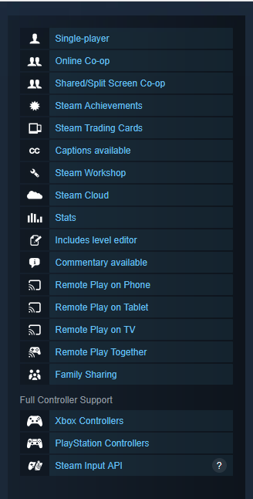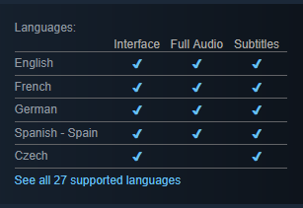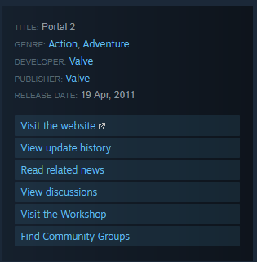
One part that is not decided upon by the author is the video game tags which are described on the video game’s page as “Popular user-defined tags” (Steam, n.d.). This can be seen below:

Because of this, any data analysis performed with these tags should not be evidence for any conclusions and should instead be the foundation for further research. For the website, these user defined tags will be the basis for sorting video games.

Methodology
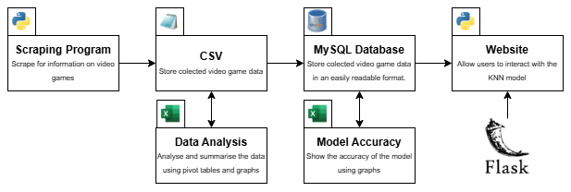
Figure 1: Development Process
Overall, the main goal of this project is to create a website that allows for users to search for video games similar to ones they already like. To achieve this, this project will be split into the following parts which can be seen in the above diagram:
- Scraping program: As previously described, this program will go over the target website (in this case, Steam), and collect data about various video games. This should be limited to low number of video games to avoid affecting Steam with high amounts of traffic and to avoid the possibility of running out of storage or the program taking too long.
- CSV: The data is then saved using the comma separated values format which will then be normalised using Excel or Python and analysed for useful information (which will be presented in the results section of this report).
- MySQL database: The normalised data will be loaded into a MySQL database using Python. This database will work alongside the final part:
- Website: This will be what the user will use to search for video games using data from the MySQL database.
Once the website has been created, the final step will be to review the scraping program, the database and the website to see how well they meet the goals the project wishes to achieve and to determine what can be done to all parts to improve them for future use.

Design/Plan

Data Plan

Target Website
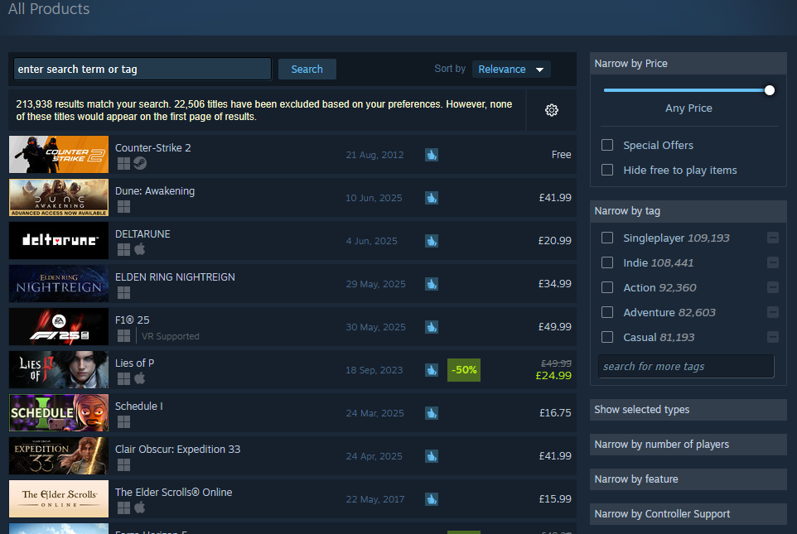
Figure 2: Steam's All Products Page
For the scraping program to work, it needs a target. The target in this case is the previously mentioned online video game retailer, Steam.
Steam has hundreds of thousands of video games available to collect data from (the above screenshot shows 225330 games for an empty search). As stated previously, all data on each video game page is submitted by the developers themselves and this page in the screenshot meets the previously mentioned requirement of there being a page with a list of all games which will make the scraping program easier.
This page also gives the scraping program a lot of ways to sort the list if needed.

Scraping
For the website to work, it needs a database full of information about various video games and that information needs to describe those video games in different ways to differentiate all of them. To get this data, a scraping program will used that will be programmed in Python.
To do this, several libraries could be used:
- Requests: This library allows Python to send HTTP requests to targeted web pages. More specifically for this project, the HTML can be requested which contains the information that would be displayed on a webpage (Pypi, n.d., -a).
- Beautifulsoup: This library is a HTML (and XML) parser that allows for easy manipulation and searching of a HTML tree (Pypi, n.d., -b).
- Selenium: This library allows Python to take control of a browser (Pypi, n.d. -c) in a programmatic way which allows for web scraping like the requests library but in a browser instead of just a HTML file (GeeksForGeeks, 2025).
- Schedule: This library allows for the scheduling of Python functions allowing for Python functions to be run periodically without a human needing to run it again (Pypi, n.d. -d).
(GeeksForGeeks, 2025)
The next part of this project learning how scraping works which will involve learning these libraries and deciding which of them (or others) should be used.
For the scraping program itself, the target website must have a page that lists all of its games. Using this page, the following should be done for each game in the list:
- Access the link to the game’s page.
- Systematically go through the game page’s HTML to get information the video game.
- Save the video game’s information gathered by appending it to a CSV file.
- Return to the video game list and start again on the next game in the list.
When looking at the typical Steam game page. There are at least ten specific points of data that would be useful to scrape. They are:
- Title: The name of each video game. This is not essential to data analysis but is necessary for when each video game is put on the website. The title can be found on both the all games page and on each game’s page as well.
- Description: Each game’s description which can be found on the game’s page in both a short version at the top of the page and a longer version lower in the page. The description is not useful for data analysis and so only be used on the website to describe each game to the user.
- Release date: The date when each game was released. This is useful for data analysis as it allows for the sorting of data by date. This will also be used on the website for the user to see.

Figure 3: Steam Developers and Publishers
- Developer(s). The people or companies that produced each game. Some games, as shown above, have multiple developers separated by commas. Data analysis can be done on the developers to determine, for example, the developer with most expensive games. This will be included in the website.
- Publisher(s). The company or companies that help to publish each game. As with the developers, some games have multiple publishers. This will be used for data analysis for the same reason as the developers. This will be included in the website.
- User defined tags. Mentioned previously, the user describe the content of each video game. This will mostly be useful in the website but will still be used in data analysis.
- Price. Very useful for data analysis when used in conjunction with the previous mentioned data. This will be used on the website.
Figure 4: HTML of Game Features
- “Features”. The features seem to describe the gameplay features that make up a game such as the game being singleplayer or multiplayer, what the game can be played on, if the game has achievements or if there are any third part agreements that need to be made to play the game. This section does not have a header and so the name of this data is taken from the HTML where it is called “game_area_features_list_ctn”. This will be useful for data analysis just like user defined tags and will also be on the website.
- Languages. The game’s supported languages. This is laid out on each game’s page as a table which describes which parts of the game support which language (E.G: A game’s interface might support English, but it might not have English audio). This will be used on the website to show supported languages and will be used in data analysis.
- Genre. The game’s genres. This is very similar to user tags but is more general. This will be used in data analysis and on the website.

Saving Format (.CSV)
A comma separated values (Creativyst Software, n.d.) (Microsoft Support, n.d.) file is a filetype that stores tables in plaintext with each row and column being separated by commas (Microsoft Support, n.d.). Both Creativyst Software (n.d.) and Microsoft (n.d.) state that CSV files make it easier to share information between multiple programs with Microsoft allowing CSV files to be imported into their Outlook software.
In Python, CSV files can be opened in the same way as text files and, with the CSV library, the CSV read method can allow Python to handle files as lists of strings with each list representing a row (Python Documentation, n.d.).
Overall, this ease of use is the reason why this project will be using CSV files. They allow the easy saving of scraped data, which can then be loaded into Excel for normalisation. This normalised data can then be saved as another CSV file that can easily be loaded into the website using Python again.

Database (MySQL)
MySQL is an open-source database management system that allows for a large amount of data to be stored and managed (MySQL, n.d.). MySQL is relational meaning that each database has multiple tables that have relationships defined by the programmer (MySQL, n.d.). As shown in its name, MySQL is programmed with the structured query language (SQL) which is a standardised language for handling databases (MySQL, n.d.).
This project will use a MySQL database to store the data scraped from the internet after said data is loaded into the database from the CSV files. The reason for using MySQL is the ease in which Python can communicate with the database to store and receive data using the MySQL Connector Python library. This library allows Python to communicate with a MySQL database through an API which allows for the database to be connected to and, through the use of a cursor, allows for the execution of SQL commands on the database (Pypi, n.d. -e).
(Continued…)

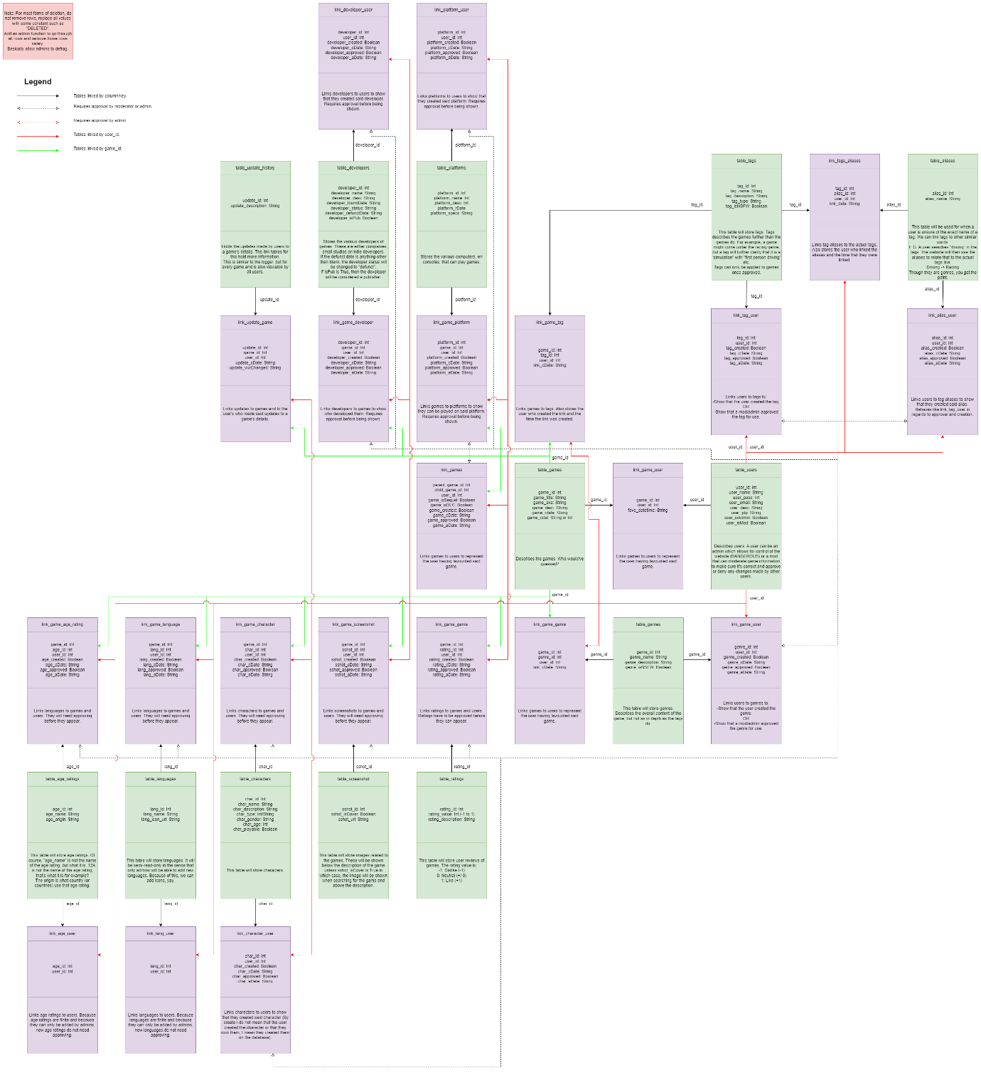
Figure 5: Database Plan
Above is a plan for the database. In it, the green boxes are regular tables that define different bits of data. The purple boxes, however, are link tables which describe how the data in two or more tables are linked. At the most basic level, the link tables hold the ids of the columns that are linked. For example, a user in the user table linked to their review in the review table will have a column in the link_user_review table that holds the user’s ID and their review’s ID.
(Continued…)

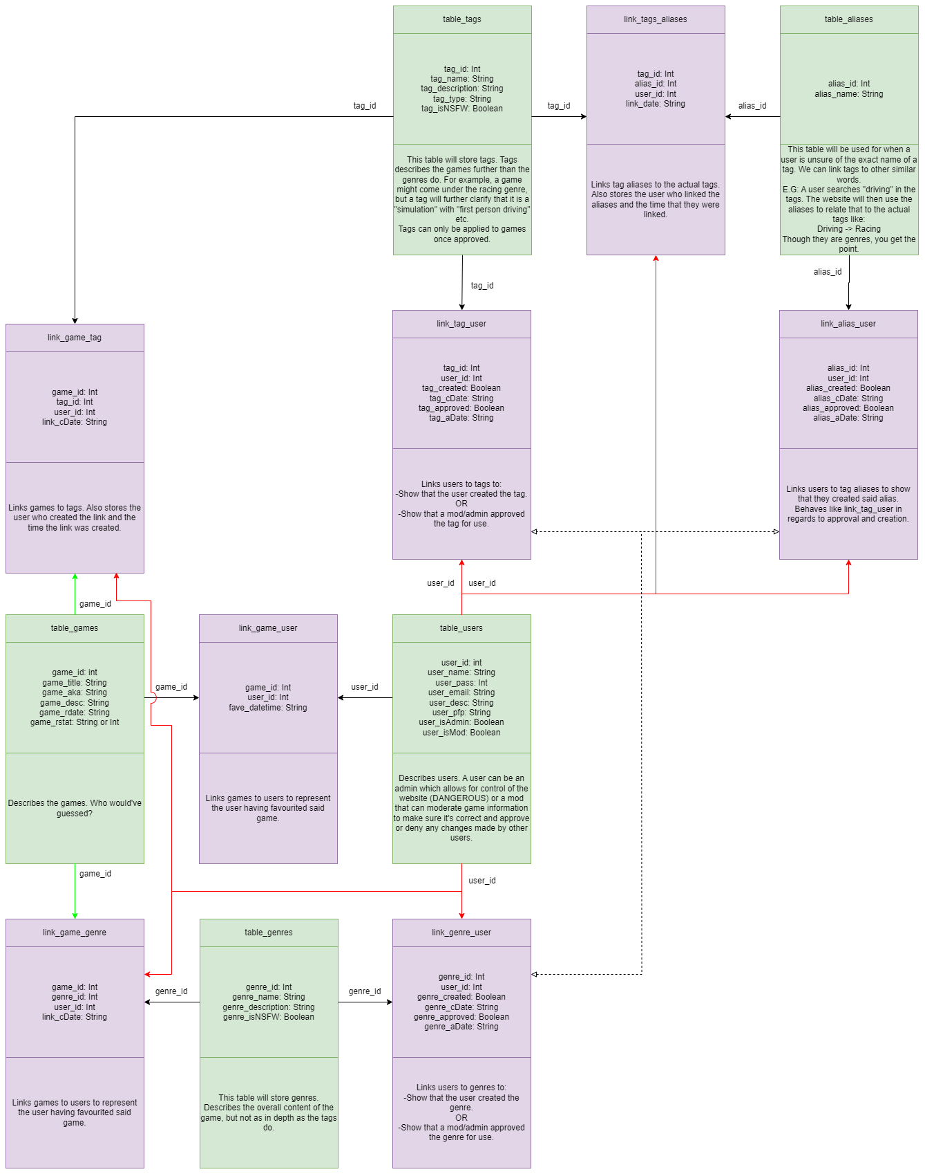
Figure 6: Database Plan (Reduced)
Here is a clearer diagram that shows only the games, users tags and tag aliases tables.

Scraping Practice
Before writing the actual scraping program, two practice scraping programs were made. One with the requests and Beautifulsoup libraries and the other with the selenium library. Primarily, this was to learn how all of those libraries work and how best to write them, but it also helped to show which was faster. For both practice programs, the special “All Pages” wiki page on Wikipedia was used. This page lists all of the wikis on the website as links. Due to this, both practice programs went through this wiki and then to each link and collected the data from each wiki page.
The page that lists all of the wikis is split into multiple pages, and on each page is a link to a single wiki page. Due to this, both programs get the HTML and search for a divider element with the class of “mw-allpages-nav” which holds all of the links. From there, all of the links are looped through and both programs visit the pages they hold. Once on each page, three elements are found, with those being:
- The title. This is sometimes a span element with the class of “mw-page-title-main” and other times it is instead a “h1” element with the id of “firstHeading”.
- The contents links. This is an unordered list element with the class “vector-toc-contents”.
- The first few paragraphs that summarise the wiki page’s topic which are found under the divider with the id of “id-content-text”.
Along with these elements, the page’s URL is also saved and after looping through all of the pages, both programs return to the all wikis page and search for a link that contains the text “Next page” and go to the next all wikis page. After doing this for a certain amount of pages specified at the start of the code, both programs save the list containing each page’s elements to a CSV file using the CSV library.
(Continued…)

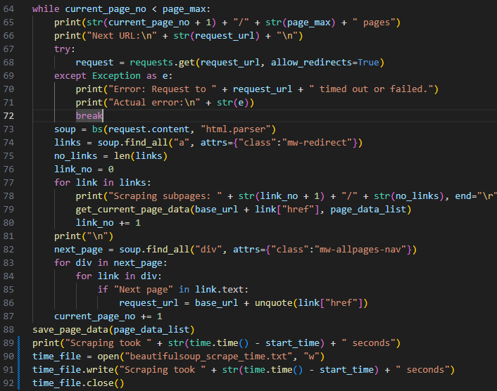
Figure 7: Beautiful Soup Scraping Main
For the requests and beautiful soup program, elements could be found with the “find all” method (after initialising beautiful soup on a request’s HTML) which returns all instances of the element requested (of which elements with specific classes or ids can be requested with the attrs attribute) which can then be looped through to handle child elements (Beautiful Soup, n.d.).
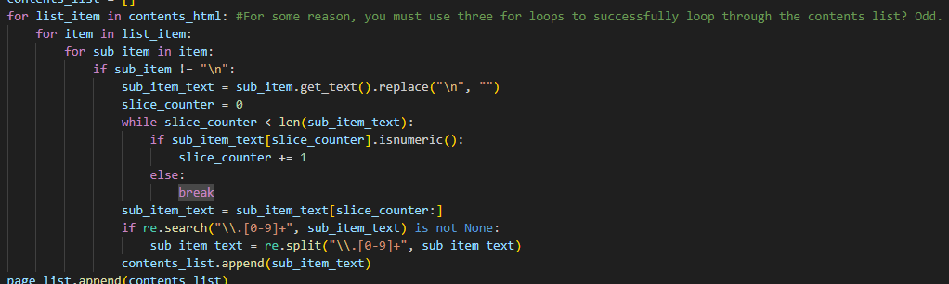
Figure 8: Beautiful Soup Scraping Per Page
However, from experimentation, Beautiful Soup does not allow for further searches on elements returned from a search. This lead to the multiple nested for loops shown above which were simply trying to find the contents elements of each page. Allowing for another search would have made this egregious looping unneeded.
(Continued…)

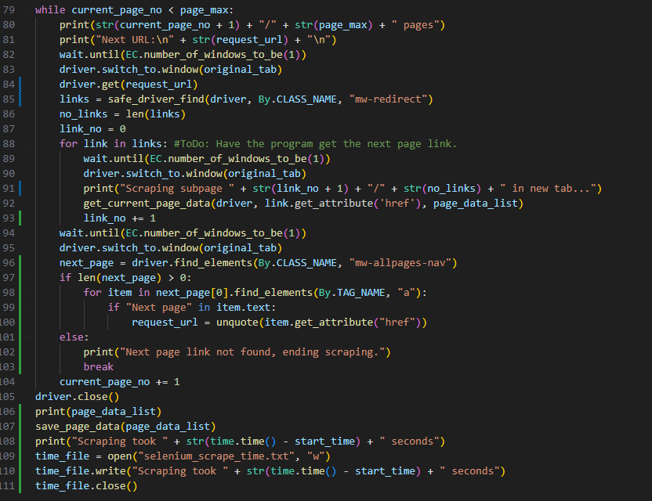
Figure 9: Selenium Scraping Main
For the selenium program (using the Firefox web browser), the code is quite similar to beautiful soup. Selenium allows for the search of elements through different tag attributes rather than searching for a specific element like in beautiful soup (Selenium). In practice, this makes it a lot easier to search for the elements you want without needing to know the other attributes of the tags you are looking for. Also, since searching the search results is possible unlike with Beautiful Soup, looping through results to find child elements is not as necessary.
However, while this makes Selenium a good option for scraping, there is one major issue with its use. It takes a lot longer to scrape than the requests library. Using the time library, both programs were timed on how long it took them to scrape the links from five pages of the all pages wiki. The Beautiful Soup program took 220 seconds (about 3 minutes), while the Selenium program took 1606 seconds (about 26 minutes).
Lastly, both programs suffered the occasional issue in which they suffered timeout errors when trying to reach Wikipedia, however, both programs worked again after running them again.
Overall, while Selenium is easier to program, its excessive amount of time taken to scrape means the project will most likely use request and Beautiful Soup for scraping, especially since, while Selenium is easier, they are quite a lot alike.

Development

Scraping Program

Main Loop and Infinite URL

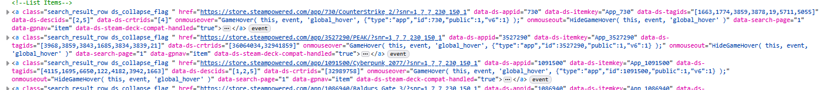

Figure 10: Per Game HTML
Before developing the scraping program, the HTML of the “all games” page on Steam was explored using the inspection tool. Each game comes its own anchor tag that contains child tags with some of the game’s information, but more specifically, each anchor contains the URL for each game as the hypertext reference (HREF).
This was useful to learn how the HTML was laid out, but a problem arose: When displaying a large amount of data, not all of it will fit on the screen. To solve this, there are many solutions, but one solution is infinite scrolling in which more data is loaded and displayed when the user reaches the end of the current data. (Interaction Design Foundation, n.d.) (Jones et al, 2016). The problem is that once the requests library receives the HTML, no additional HTML is received unless more is requested.
(Continued…)

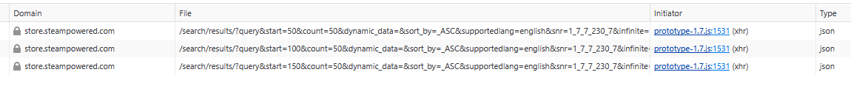
Figure 11: Steam XHR Requests
While searching for a solution to this problem, a page was found on ScrapeOps (n.d.) which suggested inspecting the network activity of the webpage for XMLHttpRequest (XHR) objects (MDN Web Docs). These XHR objects allow for communication between JavaScript and servers to send and receive data (MDN Web Docs). Inspecting the network activity on the “all games” Steam page did yield these objects along with the URL they were requesting data from. Experimenting with using the requests method on these URLs, an important variable was found within the URL called “start”. This is the game number to start the request at after which the HTML of 50 games will be returned. The count variable did not seem change the number of games returned, so it was left alone.
Figure 12: XHR Returned JSON
With this information, the original URL was abandoned and instead the XHR URL was used with the count starting at zero and incrementing by 50 after the fifty games returned were scraped. Though the XHR URL returned the data as a JSON file, the JSON method of the requests library which decodes JSON for it to be used like a dictionary in Python (Requests Documentation, n.d.). From this, the HTML could be accessed with the key of “results_html” which finally solved the infinite scrolling problem.
(Continued…)

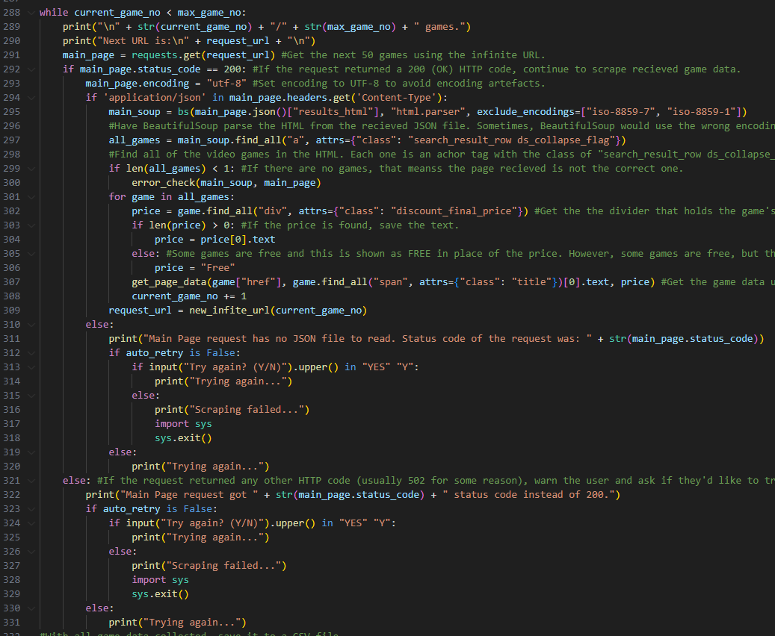
With this solution in place, the main loop of the program (which loops until the desired number of games has been reached) requests the next fifty games. To find each game in the received HTML, it is parsed by Beautiful Soup. Then, the anchor tags mentioned at the beginning of this section are found using Beautiful Soup’s find_all method which finds the requested elements (Tedboy, n.d.). In this case, the class attribute is included in the search due to the anchors having the classname of "search_result_row ds_collapse_flag”.
After finding these anchor tags, all fifty games are then iterated through and their pages scraped for data.
The main body also has some error protection against non 200 status codes on requests and the JSON file not being received. In both cases, the user is asked if they want the program to try again.

MySQL Database

Website

Results/Findings

Scraping Program & Data Analysis

MySQL Database

Website

Conclusion

References
- Beautiful Soup. (n.d.). Beautiful Soup Documentation. Beautiful Soup. https://beautiful-soup-4.readthedocs.io/en/latest/
- Castillo, M. (2013, Jun). Overwhelmed by Choices. American Journal of Neuroradiology : AJNR, 34(6), 1111–1112. https://doi.org/10.3174/ajnr.A3274
- Conklin, L., Drake, V., Strittmatter, Sven., Braiterman, Z., & Shostack, A. (n.d.). Threat Modeling Process. OWASP. https://owasp.org/www-community/Threat_Modeling_Process
- CPS. (2023, August 3rd). Computer Misuse Act. The Code for Crown Prosecutors. https://www.cps.gov.uk/legal-guidance/computer-misuse-act
- CPS. (2024, March 11th, b). Fraud Act 2006. The Code for Crown Prosecutors. https://www.cps.gov.uk/legal-guidance/fraud-act-2006
- GDPR. (n.d.). What is GDPR, the EU’s new data protection law? GDPR. https://gdpr.eu/what-is-gdpr/
- Creativyst Software. (n.d.). How To: The Comma Separated Value (CSV) File Format. Creativyst Software. https://www.creativyst.com/Doc/Articles/CSV/CSV01.shtml
- GeeksForGeeks. (2025). Python Web Scraping Tutorial. GeeksForGeeks. https://www.geeksforgeeks.org/python-web-scraping-tutorial/
- Interaction Design Foundation. (n.d.). Infinite Scrolling. Interaction Design Foundation. https://www.interaction-design.org/literature/topics/infinite-scrolling
- Iwanna, B., Rizvi, S., Ahmed, S., Dengel, A., & Uchida, S. Judging a Book By its Cover. Cornell University. https://doi.org/10.48550/arXiv.1610.09204
- Jones, K., & Martin, L. (2016). Adapting infinite-scroll with user experience in mind. DiVA. https://www.diva-portal.org/smash/record.jsf?pid=diva2%3A972535&dswid=1795
- Landuyt, D., & Joosen, W. (2022). A descriptive study of assumptions in STRIDE security threat modelling. Software and Systems Modelling, 21(6), 2311-2328. https://doi.org/10.1007/s10270-021-00941-7
- MDN Web Docs. (n.d.). XMLHttpRequest. MDN Web Docs. https://developer.mozilla.org/en-US/docs/Web/API/XMLHttpRequest
- Microsoft Learn. (2009). The STRIDE Threat Model. Microsoft Learn. https://learn.microsoft.com/en-us/previous-versions/commerce-server/ee823878(v=cs.20)?redirectedfrom=MSDN
- Microsoft Support. (n.d.). Create or edit .csv files to import into Outlook. Microsoft Support. https://support.microsoft.com/en-gb/office/create-or-edit-csv-files-to-import-into-outlook-4518d70d-8fe9-46ad-94fa-1494247193c7
- MySQL. (n.d.). 1.2.1 What is MySQL? MySQL Documentation. https://dev.mysql.com/doc/refman/8.0/en/what-is-mysql.html
- Pypi. (n.d. -a). requests 2.32.3. Pypi. https://pypi.org/project/requests/
- Pypi. (n.d. -b). beautifulsoup4 4.13.4. Pypi. https://pypi.org/project/beautifulsoup4/
- Pypi. (n.d. -c). selenium 4.33.0. Pypi. https://pypi.org/project/selenium/
- Pypi. (n.d. -d). schedule 1.2.2. Pypi. https://pypi.org/project/schedule/
- Python Documentation. (n.d.). csv – CSV File Reading and Writing. Python. https://docs.python.org/3/library/csv.html
- Pypi. (n.d. -e). mysql-connector-python 9.3.0. Pypi. https://pypi.org/project/mysql-connector-python/
- Raneri, P., Montag, C., Rozgonjuk, D., Satel, J., & Pontes, H. (2022, June). The role of microtransactions in Internet Gaming Disorder and Gambling Disorder: A preregistered systematic review. Addictive Behaviors Reports. 15, 100415. https://doi.org/10.1016/j.abrep.2022.100415
- Requests Documentation. (n.d.). Quickstartn. Requests Documentation. https://requests.readthedocs.io/en/latest/user/quickstart/
- Samuli, K. (2022, January 19th). Pricing economics of video games: a panel data study on the effects of versioning on revenue. University of Oulu Repository. https://urn.fi/URN:NBN:fi:oulu-202201191079
- Selenium. (n.d.). Locating Elements. Selenium. https://selenium-python.readthedocs.io/locating-elements.html
- ScrapeOps. (n.d.). How To Scroll Infinite Pages in Python. ScrapeOps. https://scrapeops.io/python-web-scraping-playbook/python-scroll-infinite-pages/
- Smith, Vincent. (2019). Go Web Scraping Quick Start Guide (1st Edition). Packt Publishing.
- Steam. (n.d.). Portal 2. Steam. https://store.steampowered.com/app/620/Portal_2/
- Steamworks. (n.d.). Steam Direct (Joining The Steamworks Distribution Program). Steam. https://partner.steamgames.com/steamdirect
- Tedboy. (n.d.). Beautiful Soup Documentation. Github. https://tedboy.github.io/bs4_doc/
- United Kingdom. (n.d.). Data protection (The UK’s data protection legislation). United Kingdom. https://www.gov.uk/data-protection
- UKCS. (n.d.). UK copyright law: An introduction (The Copyright, Designs and Patents Act 1988). The UK Copyright Service. https://copyrightservice.co.uk/copyright/uk_law_summary
- Xiao, G. (2021). BAD BOTS: REGULATING THE SCRAPING OF PUBLIC PERSONAL INFORMATION. Harvard Journal of Law & Technology, 34 (2), 701.
- Zhao, B. (2017). Web Scraping. Encyclopedia of Big Data. https://link.springer.com/rwe/10.1007/978-3-319-32001-4_483-1
ALT: https://www.researchgate.net/profile/Bo-Zhao-3/publication/317177787_Web_Scraping/links/5c293f85a6fdccfc7073192f/Web-Scraping.pdf

